**SMART SPENDING SYSTEM**

**(SSS)**



***Team 12- Vision Quest***

* Avinash Banala - 5
* Sai Smaran Chinthala – 11
* Rahul Nagavalli - 28
* Swetcha Reddy Vangala – 41

***PROJECT PLAN***

***ZENHUB***

**ISSUES (Avinash)**

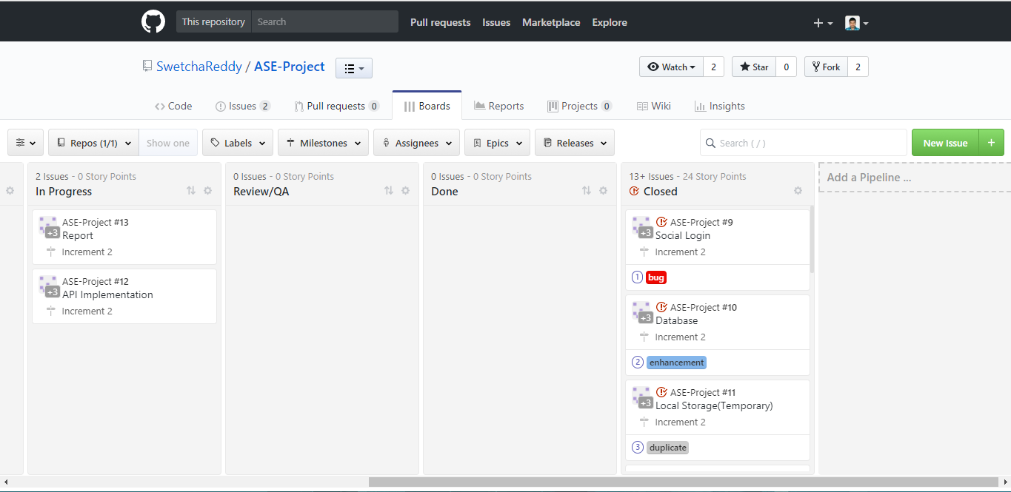

**CLOSED ISSUES**

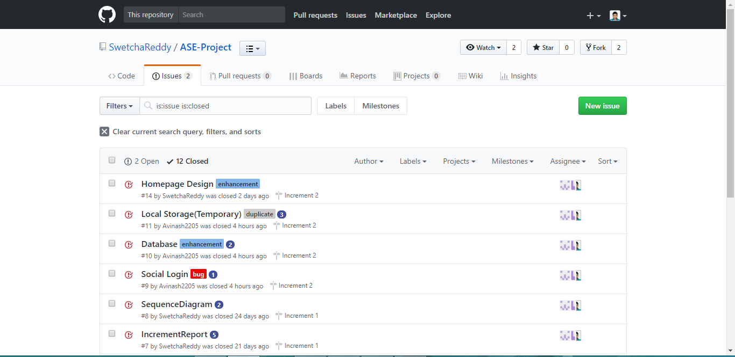

**BURNDOWN CHART**

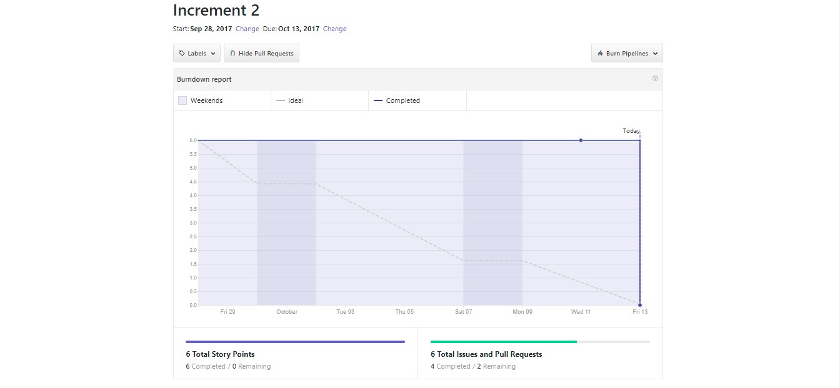

**TEAM MEMBERS**

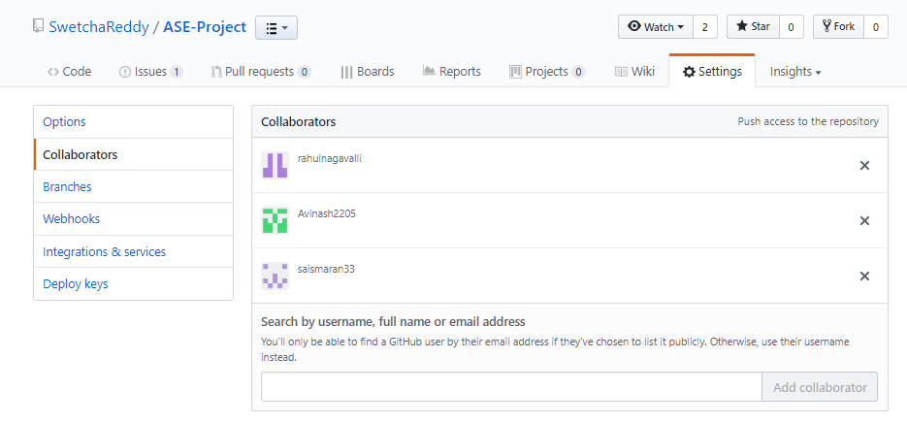

***SECOND INCREMENT REPORT***

***REST APIs USED (SWETCHA)***

For this application to become a global application, for this to be accessible to people all over the world, a currency API is required. The API which we use for this application is Fixer.

**FIXER**

Fixer is a free JSON API for current and historical Foreign exchange rates published by the European Central Bank.

This API makes the application useful all over the world.

***DESIGN***

***WIREFRAMES***

**LOGIN PAGE (RAHUL)**

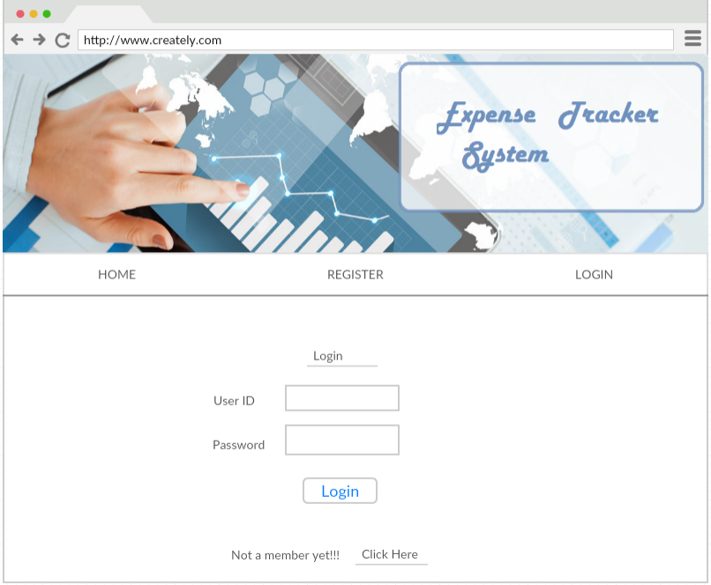

**REGISTER PAGE (SMARAN)**

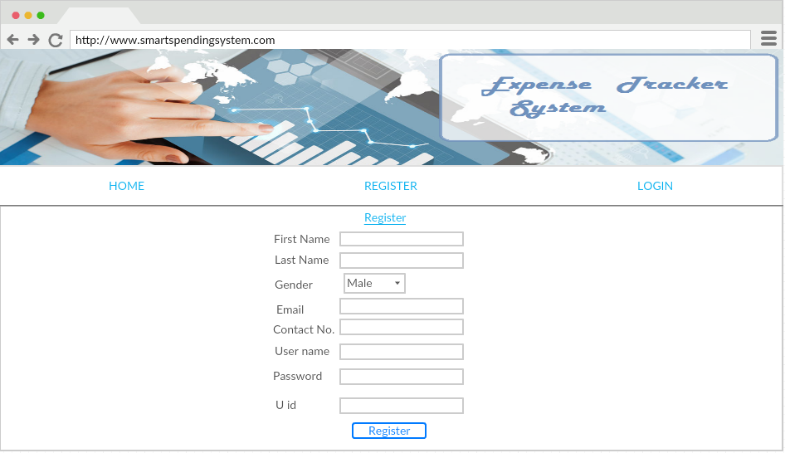

**APPLICATION PAGE (SWETCHA)**

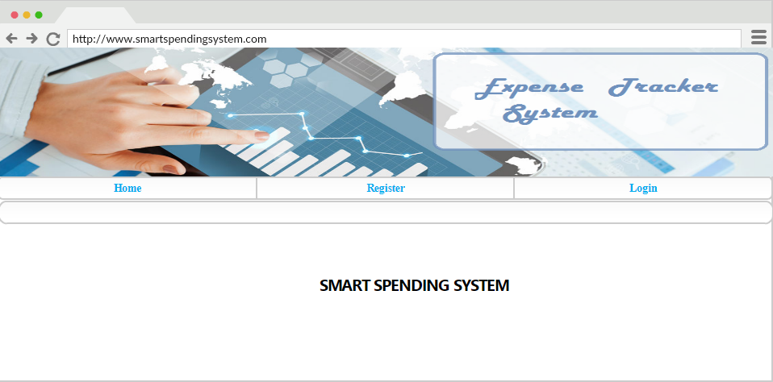

**ADD INCOME (RAHUL)**

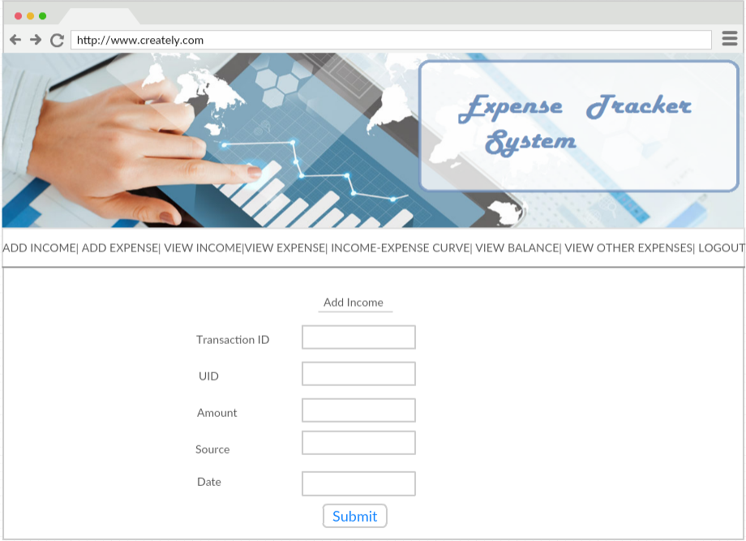

**ADD EXPENSE (SMARAN)**

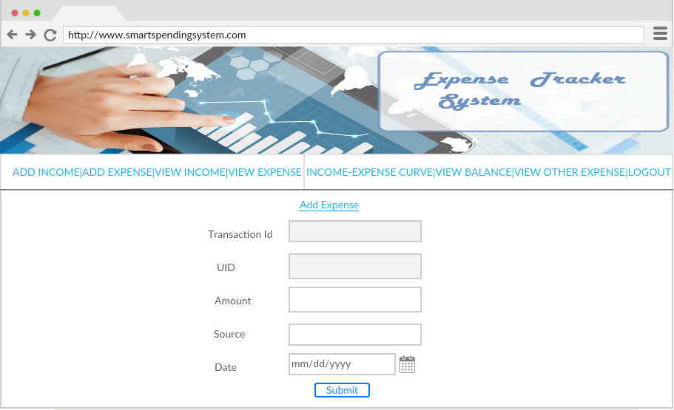

**VIEW INCOME (SWETCHA)**

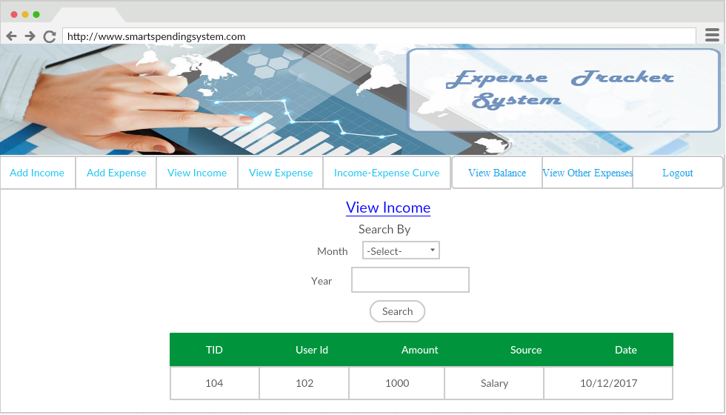

**VIEW EXPENSE (AVINASH)**

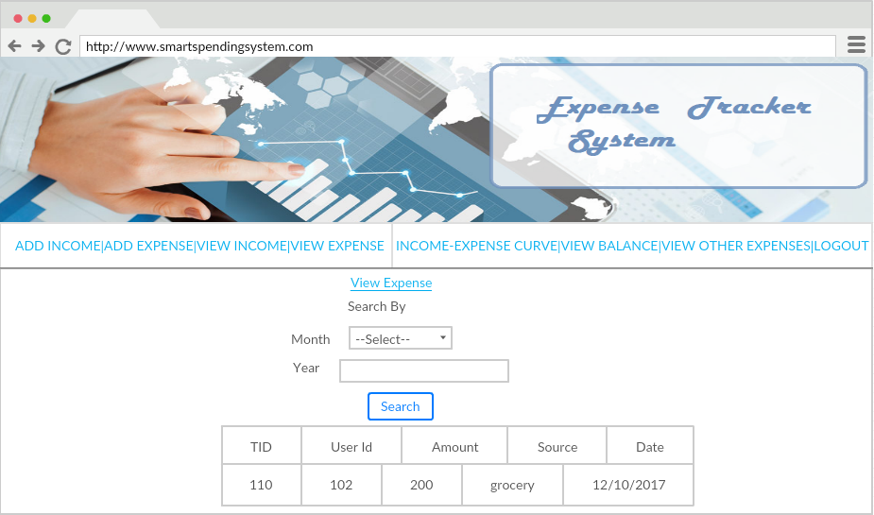

**VIEW BALANCE (AVINASH)**

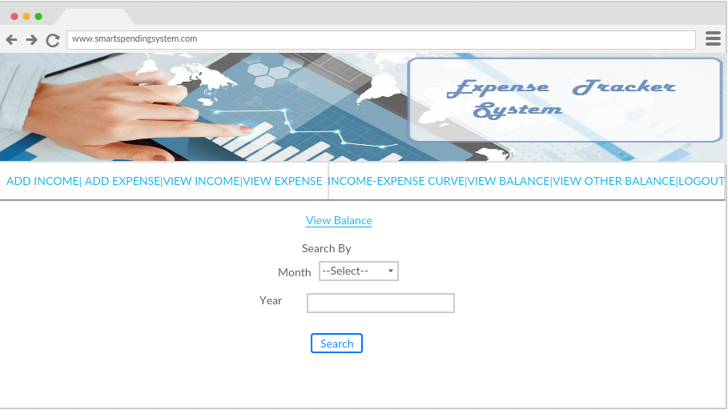

***ARCHITECTURE DIAGRAM (SWETCHA)***

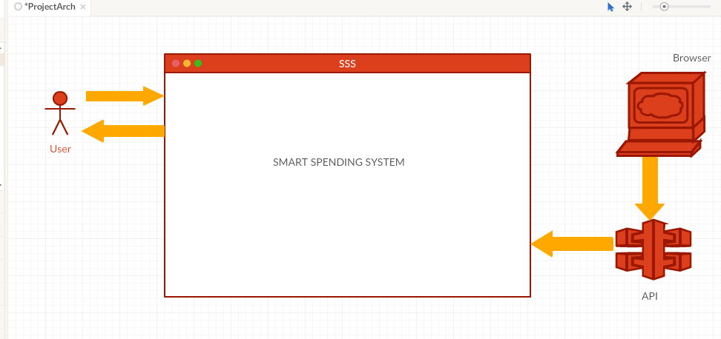

***CLASS DIAGRAM (SMARAN)***

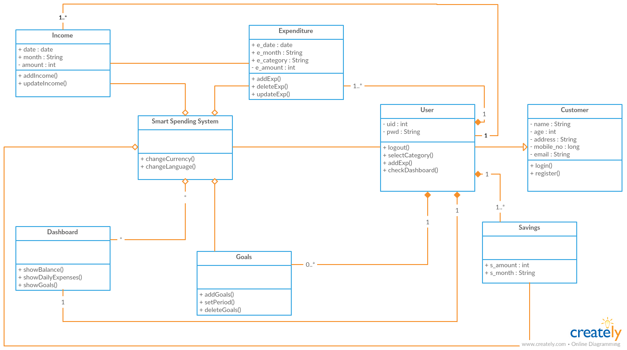

***SEQUENCE DIAGRAM (SWETCHA)***

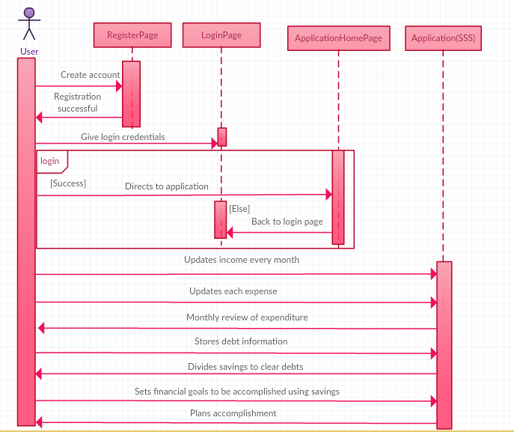

***USER STORIES (SWETCHA, AVINASH)***

* As a user, I want to register with the web application, so that I can start using the Smart Spending System.
* As a user, I want to login to the application, so that I can access my account.
* As a user, I want to keep a track on my savings, so that I can achieve my goals.
* As a user, I want to keep a track on my savings, so that I can clear my debt.
* As a user, I want to review my monthly expenditure, so that I can plan my budget better for the next month.
* As a user, I want to add the income for the current month, so that I can check my income for each and every month.
* As a user, I want to add the expense for the month in a particular year, so that I can keep my expense tracking.
* As a user, I want to view my income so that I can plan my budget.
* As a user, I want to view my expenses so that I can keep a track of on my expensed.
* As a user, I want to view my balance so that I can be able to know the amount left.

***USE CASE DIAGRAM (RAHUL)***

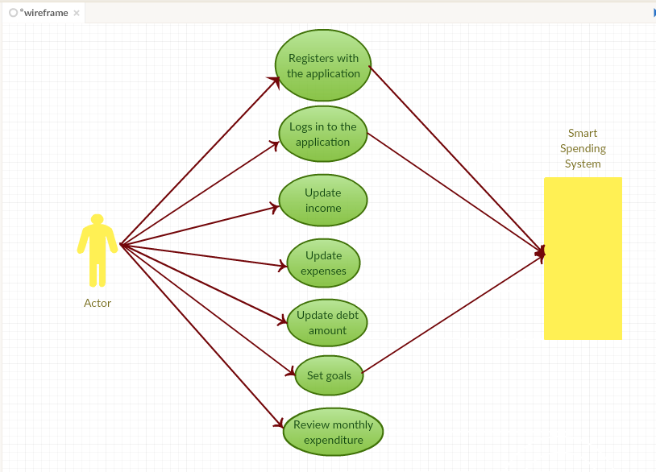

***TESTING (SWETCHA, AVINASH)***

|  |  |  |  |  |
| --- | --- | --- | --- | --- |
| **Test Case no.** | **Test Case** | **Description** | **Expected**  **Output** | **Result** |
| 1. | Successful  User Authentication | The user should login with username and password. | Successful Login | Pass |
| 2. | Unsuccessful  User  Authentication | The user logs in with wrong username or password | Login unsuccessful with error-Invalid username or password | Pass |
| 3. | Registration by new user | Admin accepts registration details from the user | Successful registration and transition to Login page | Pass |
| 4. | Add Income | User can add his income for the month | Successful authentication of income is added | Pass |
| 5. | Add Expense | User can add his expense for the month | Successful type of expense is added | Pass |
| 6. | View Income | User can view his income. | Income is viewed for the month | Pass |
| 7. | View Expense | User can view his expense. | Expense is viewed for the month | Pass |
| 8. | View Balance | User can view his balance based upon his savings and expenses | Balance is viewed for the particular month | Pass |

***IMPLEMENTATION***

**LOGIN PAGE (RAHUL)**

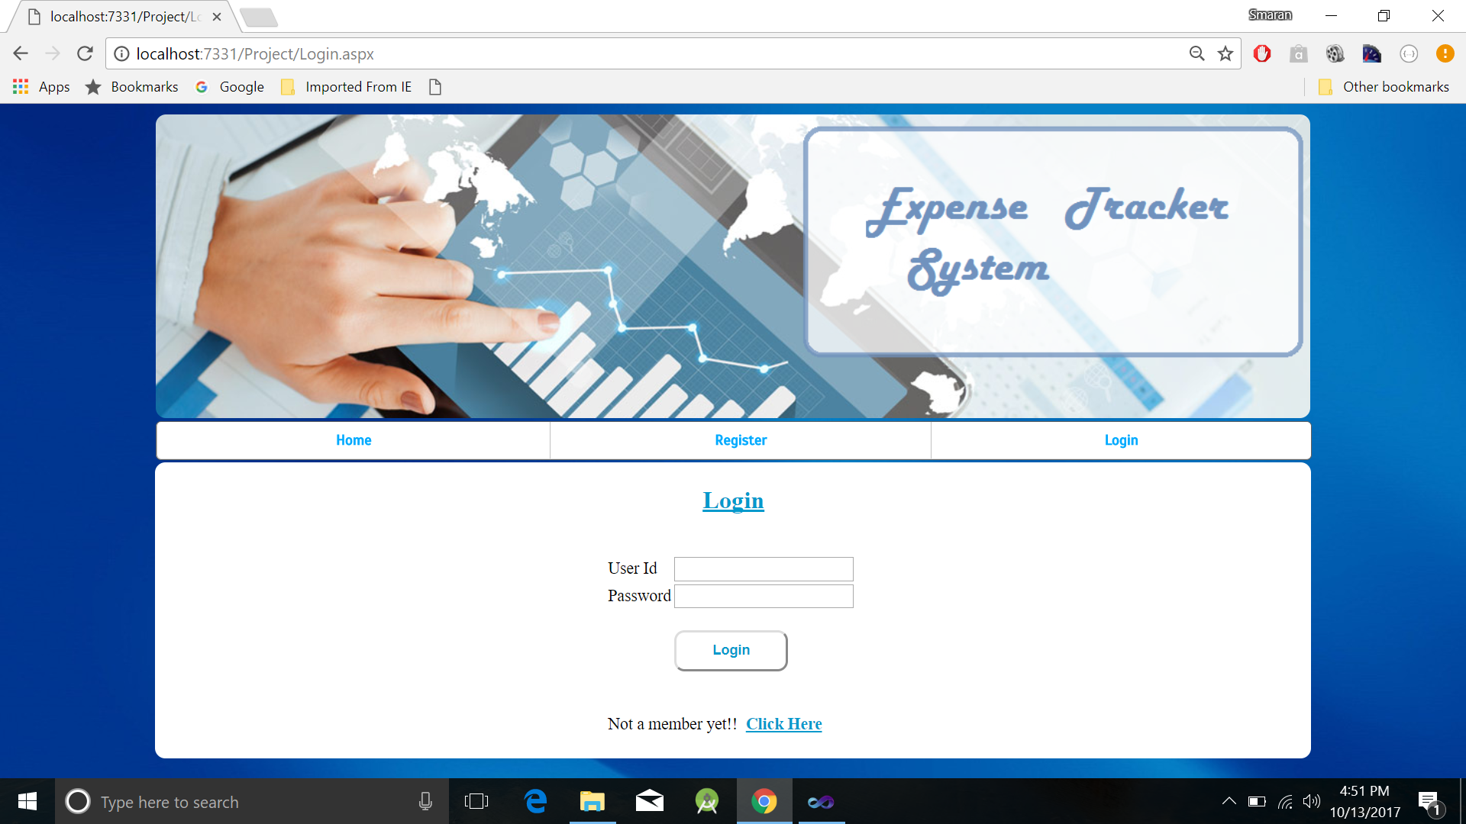

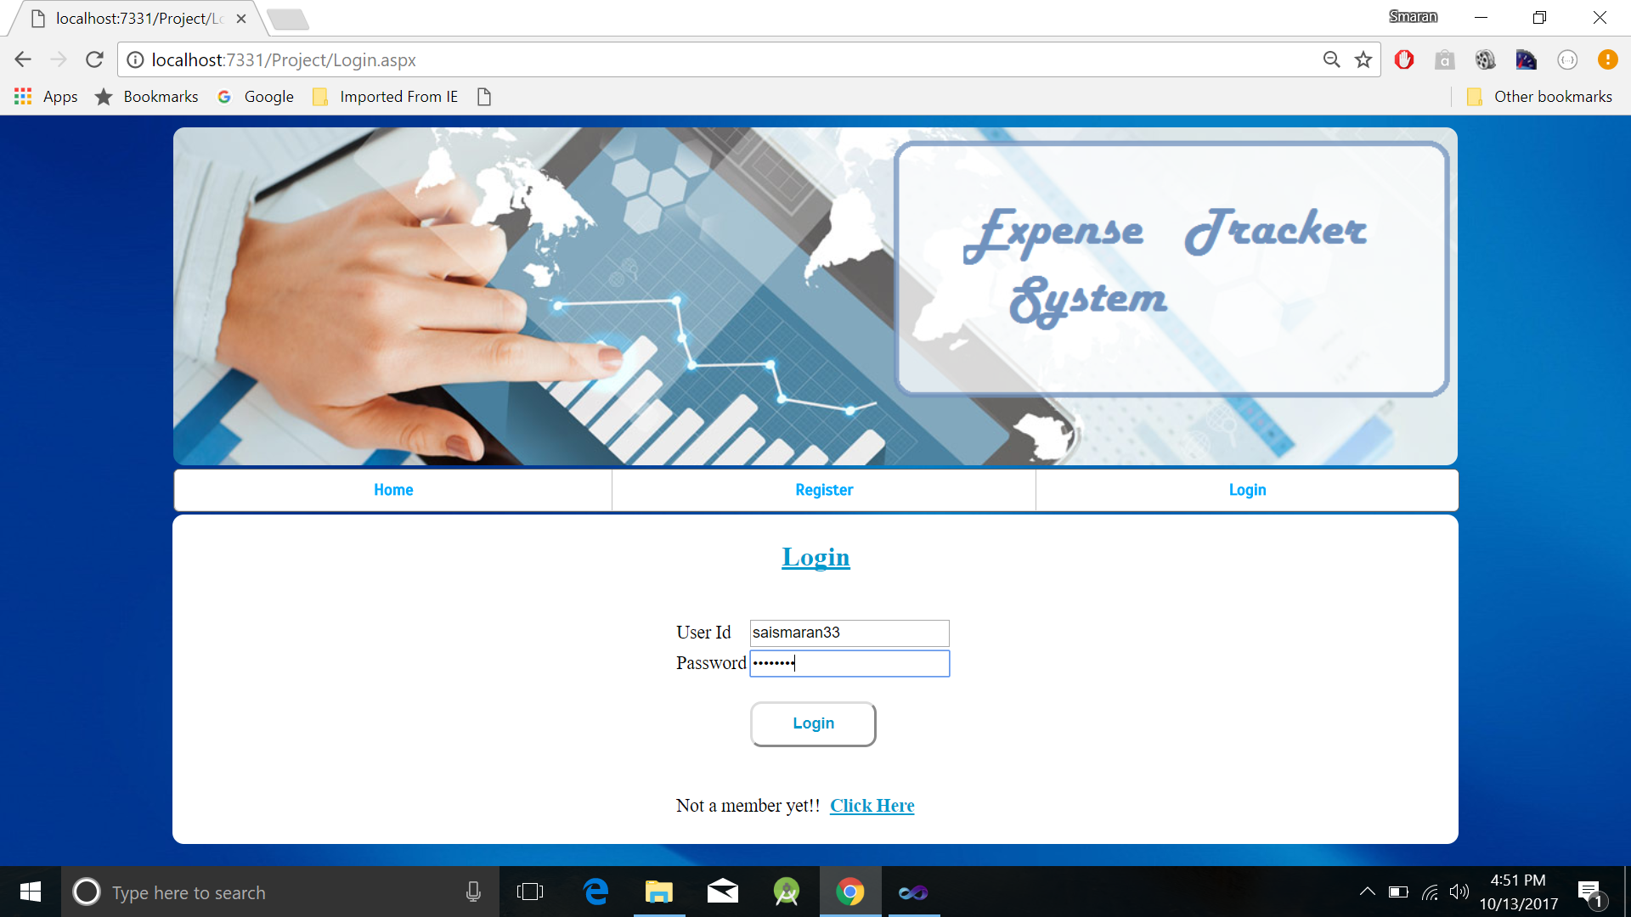

**REGISTER PAGE (SMARAN)**

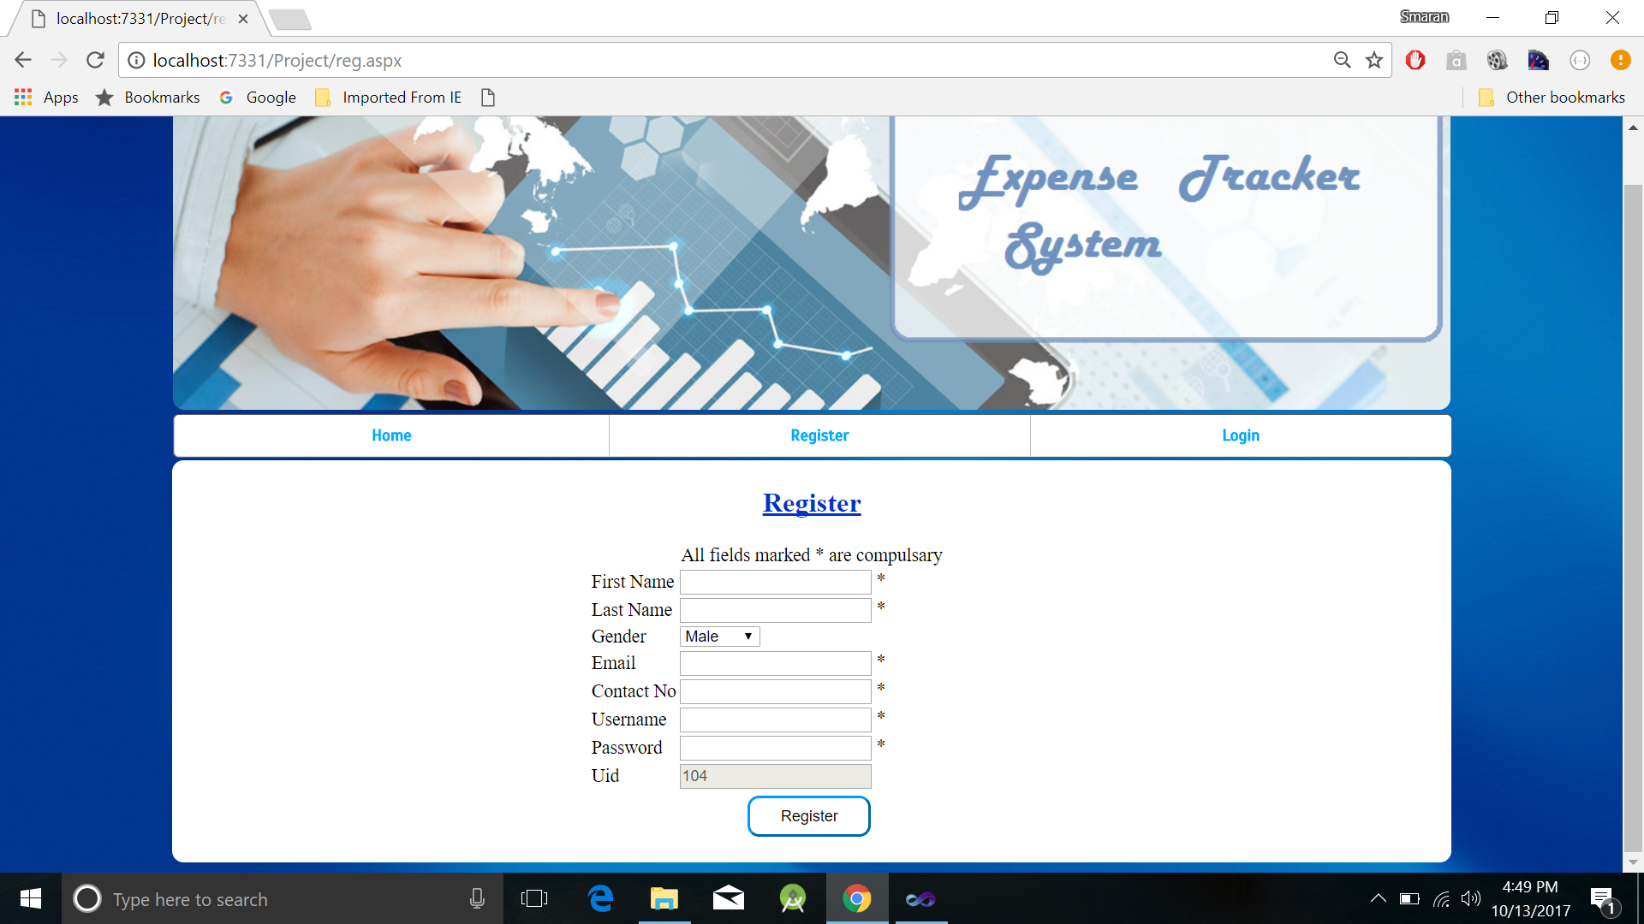

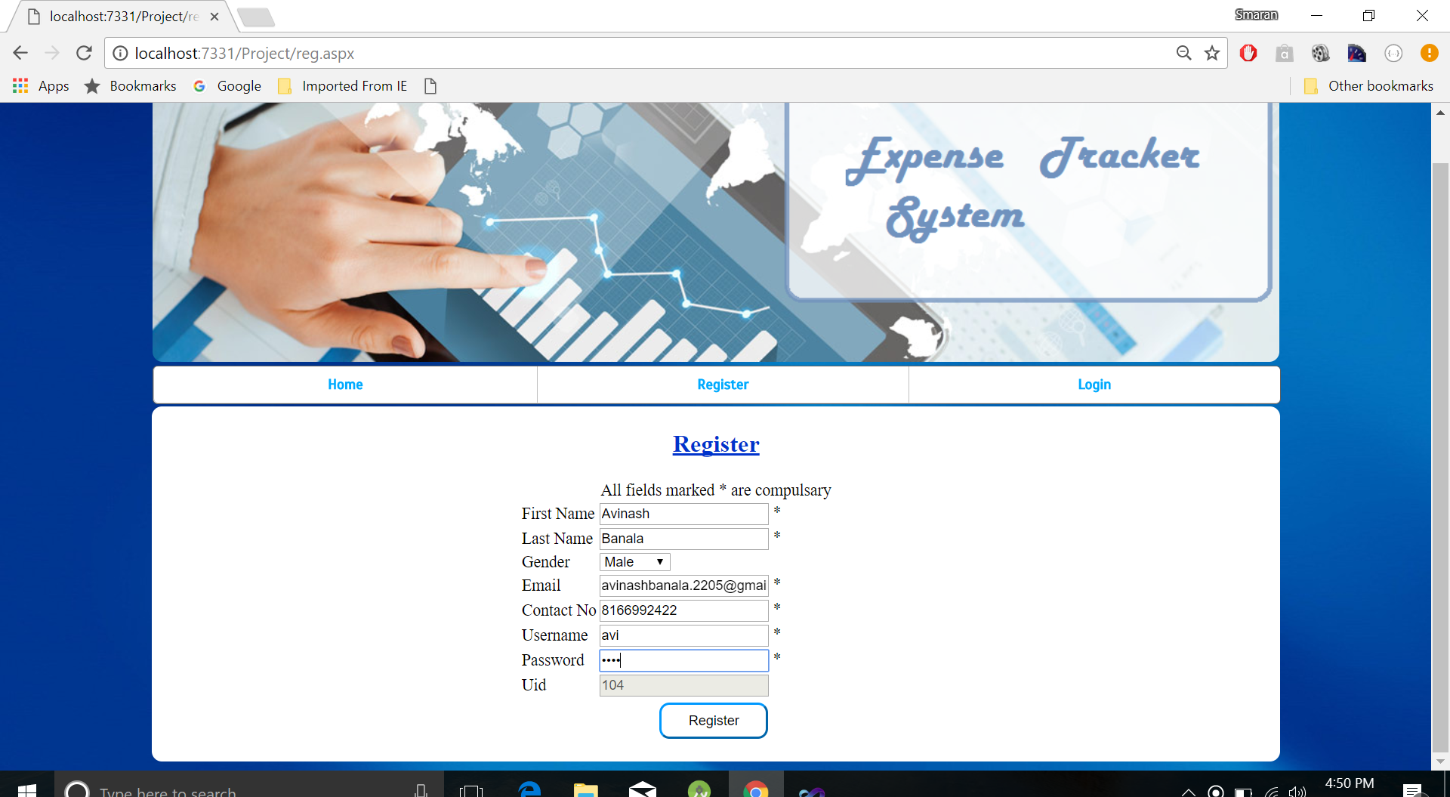

**APPLICATION HOME PAGE (SWETCHA)**

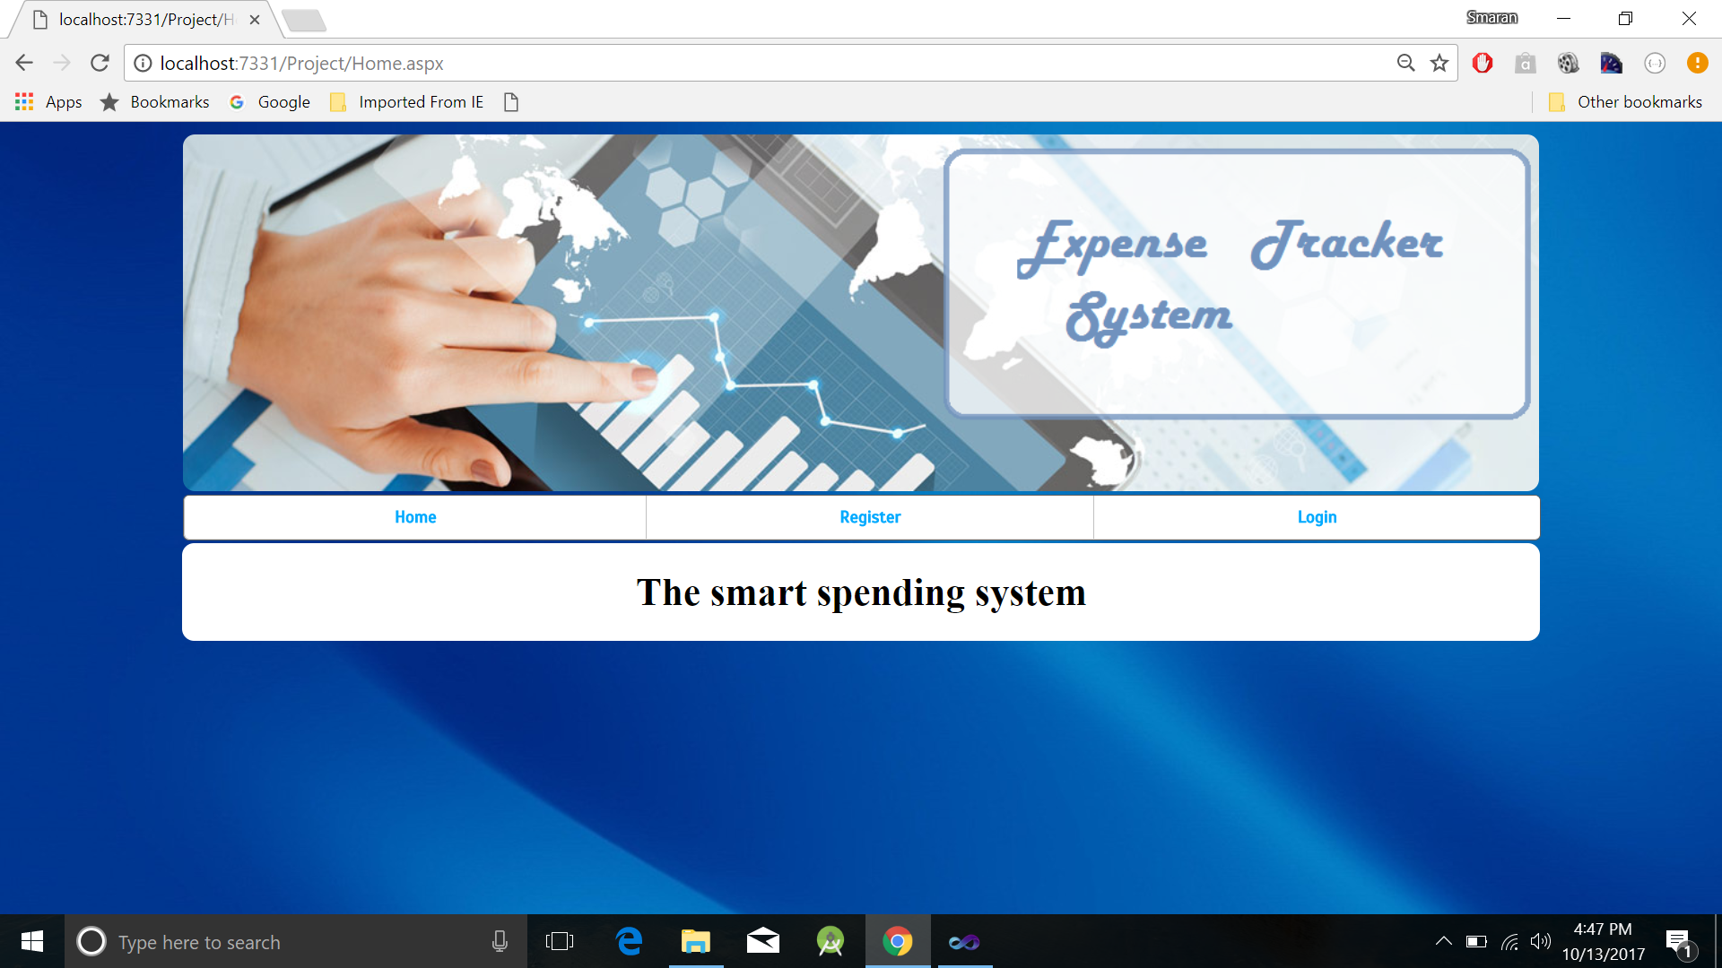

**ADD INCOME (RAHUL)**

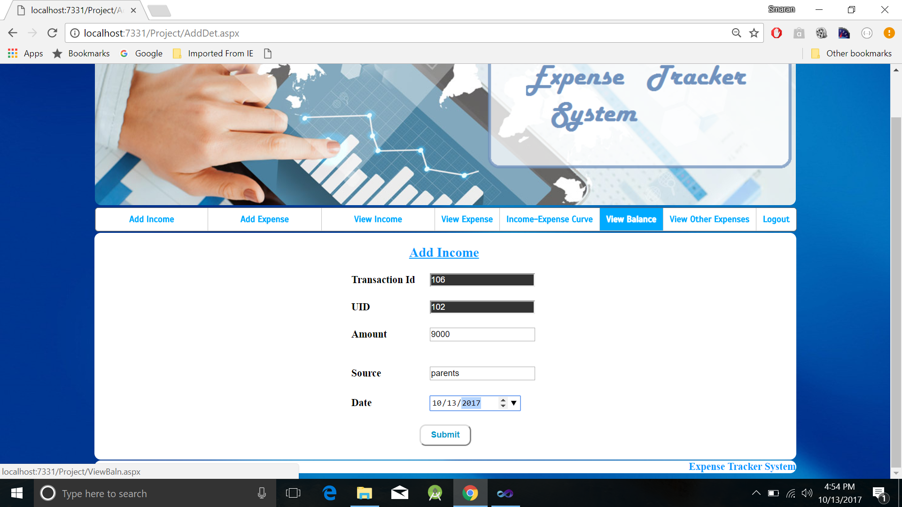

**VALIDATION FOR INCOME (RAHUL)**

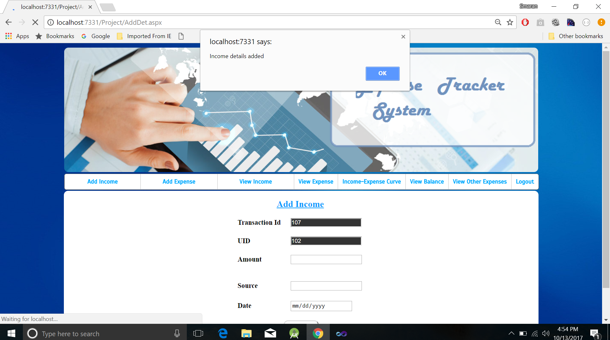

**ADD EXPENSE (SMARAN)**

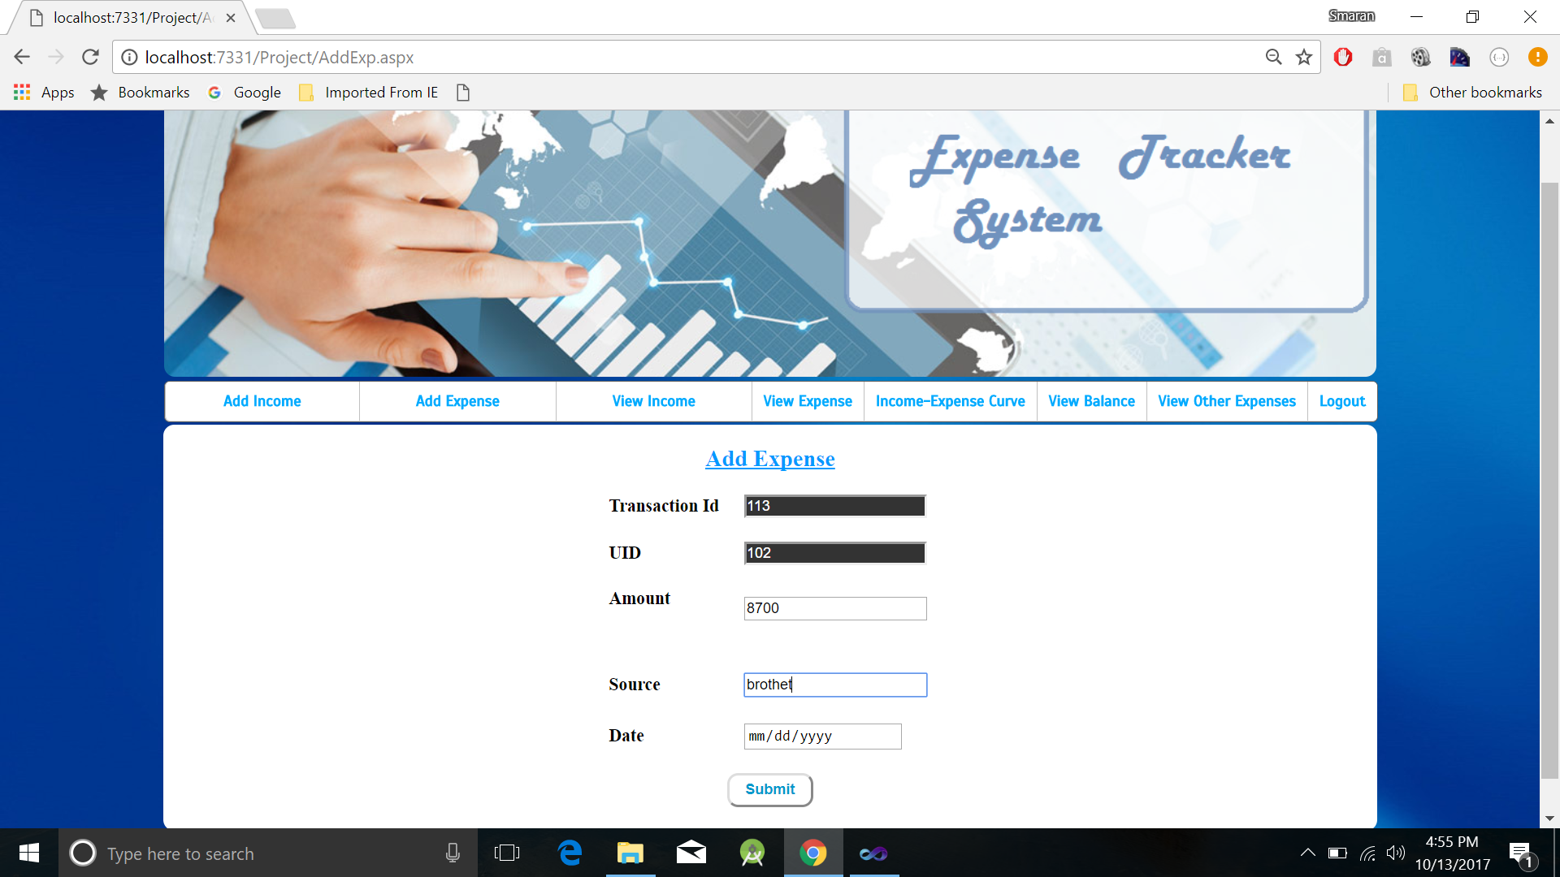

**VALIDATION FOR EXPENSE (SMARAN)**

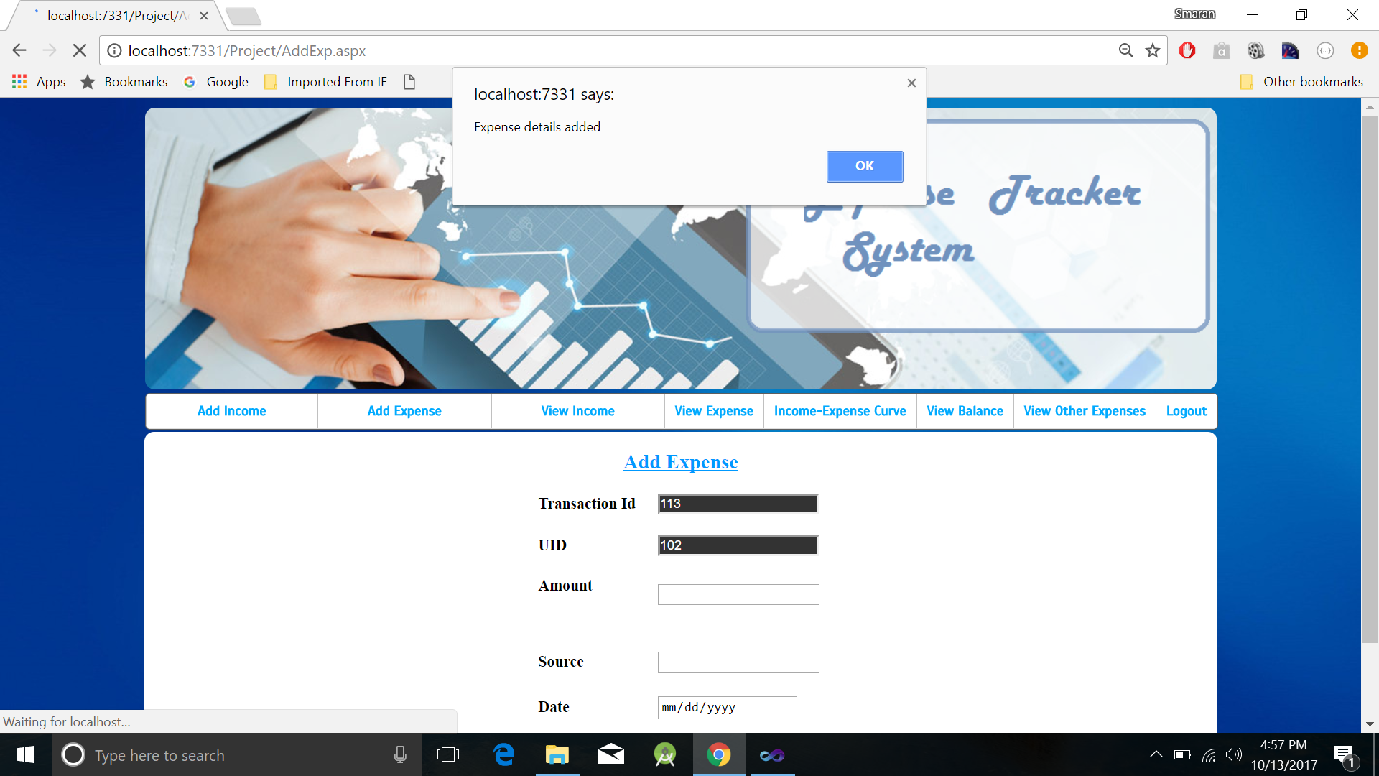

**DATE VALIDATION (SMARAN)**

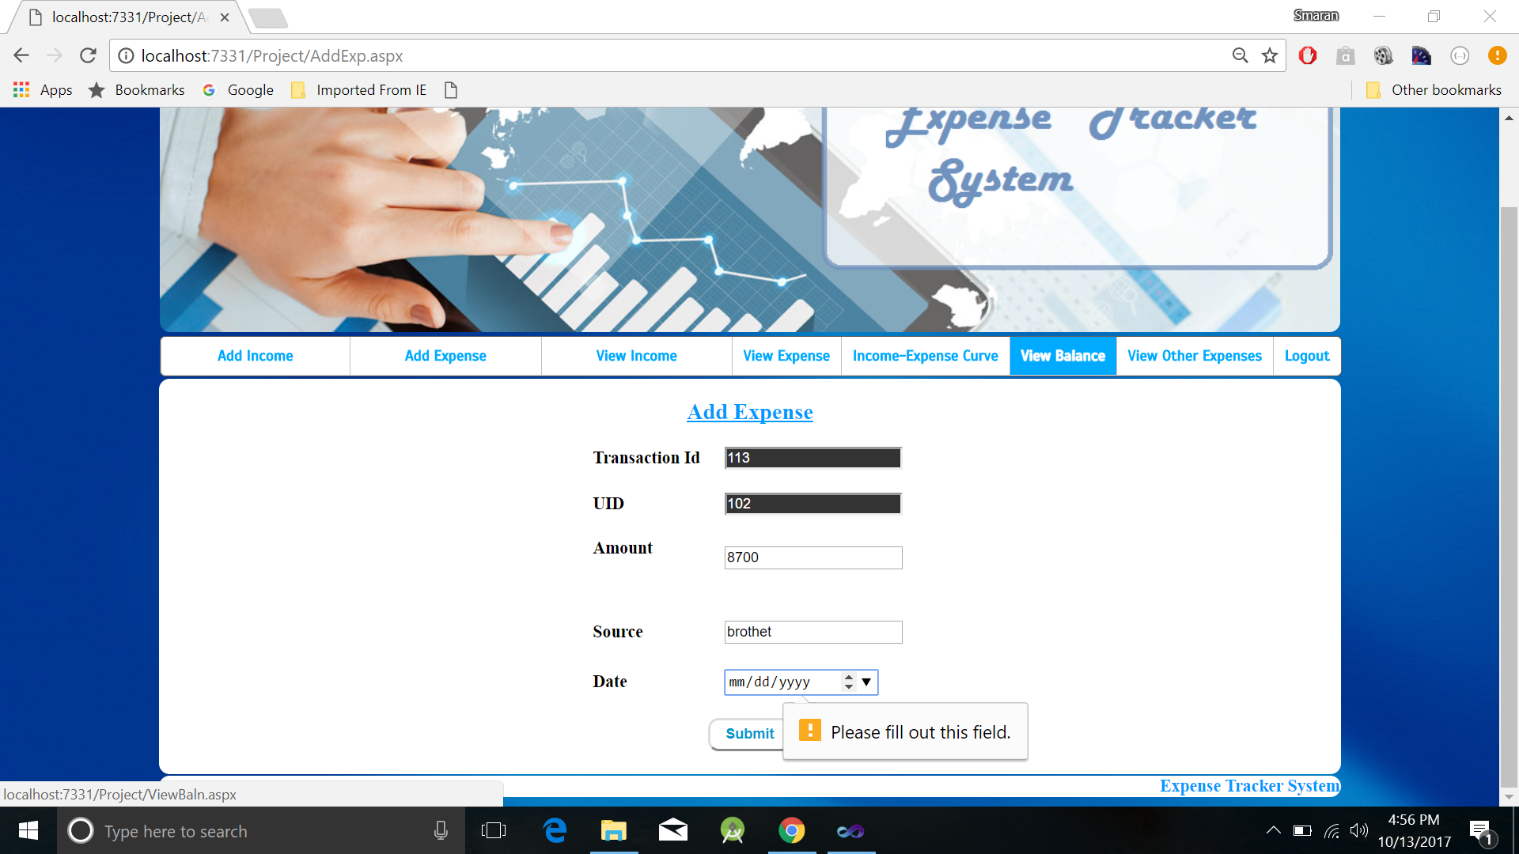

**VIEW INCOME (SWETCHA)**

**OTHER MONTH:**

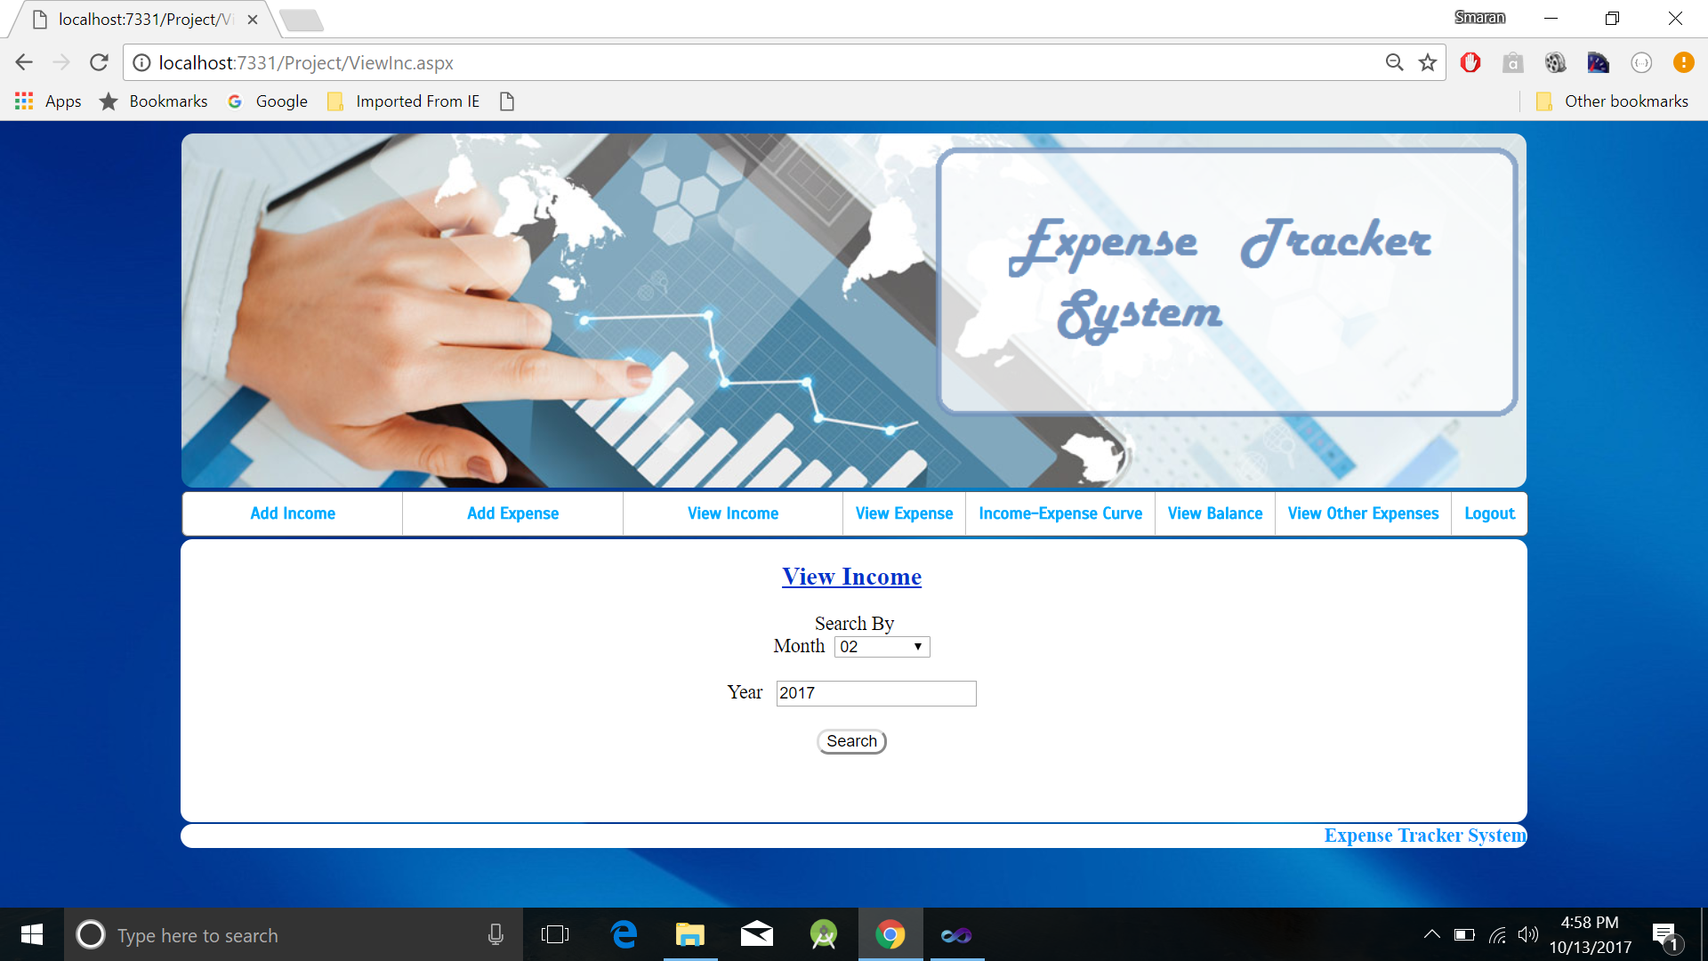

**CURRENT MONTH**

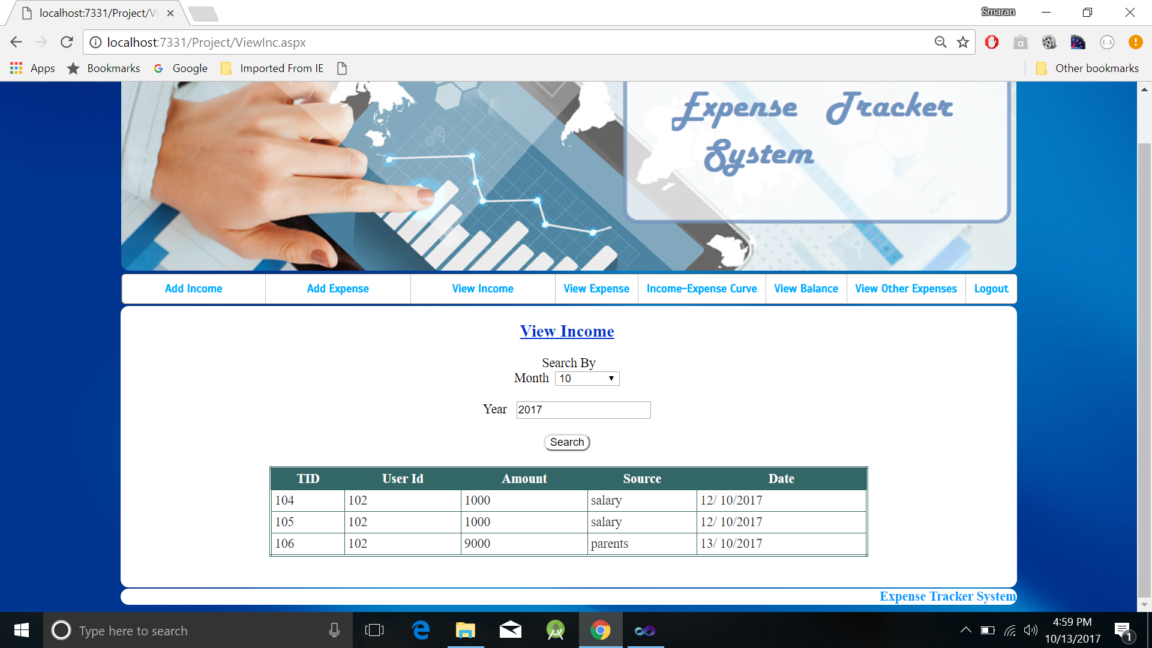

**VIEW EXPENSE (AVINASH)**

**OTHER MONTH**

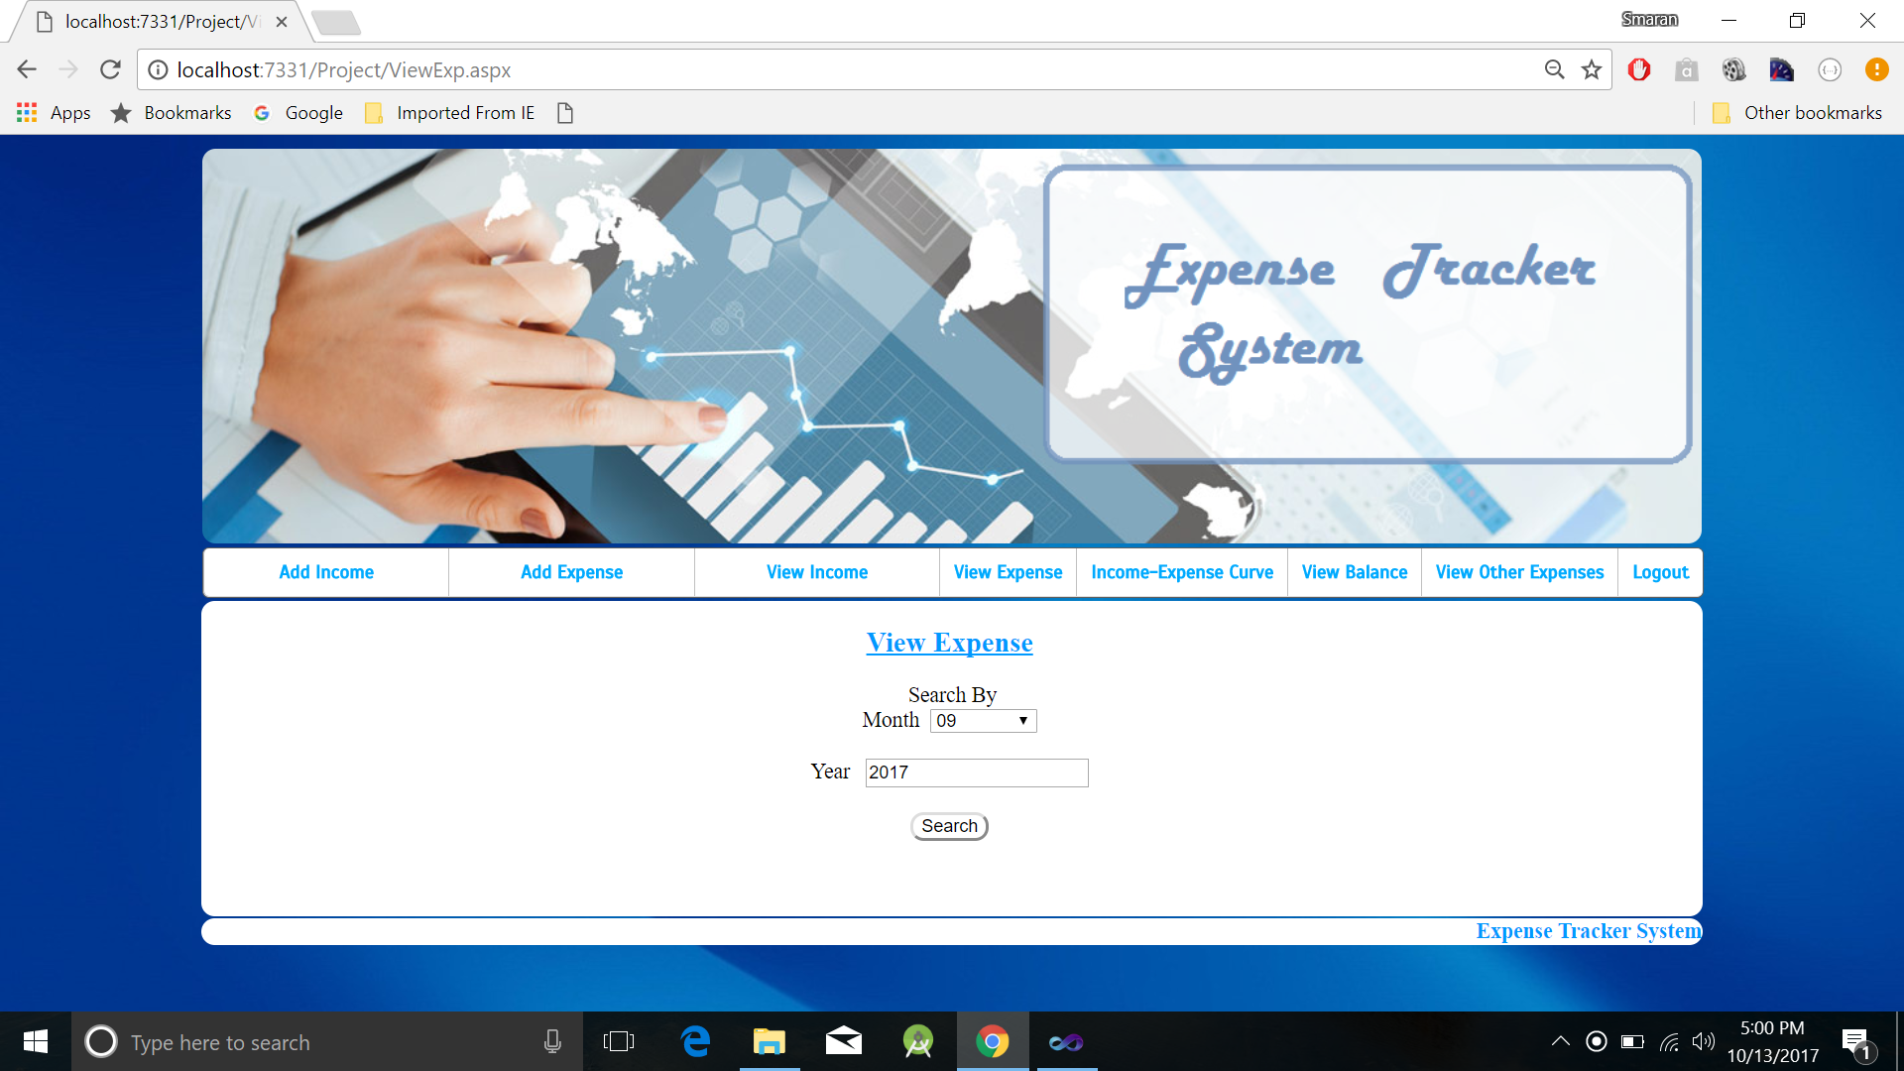

**CURRENT MONTH**

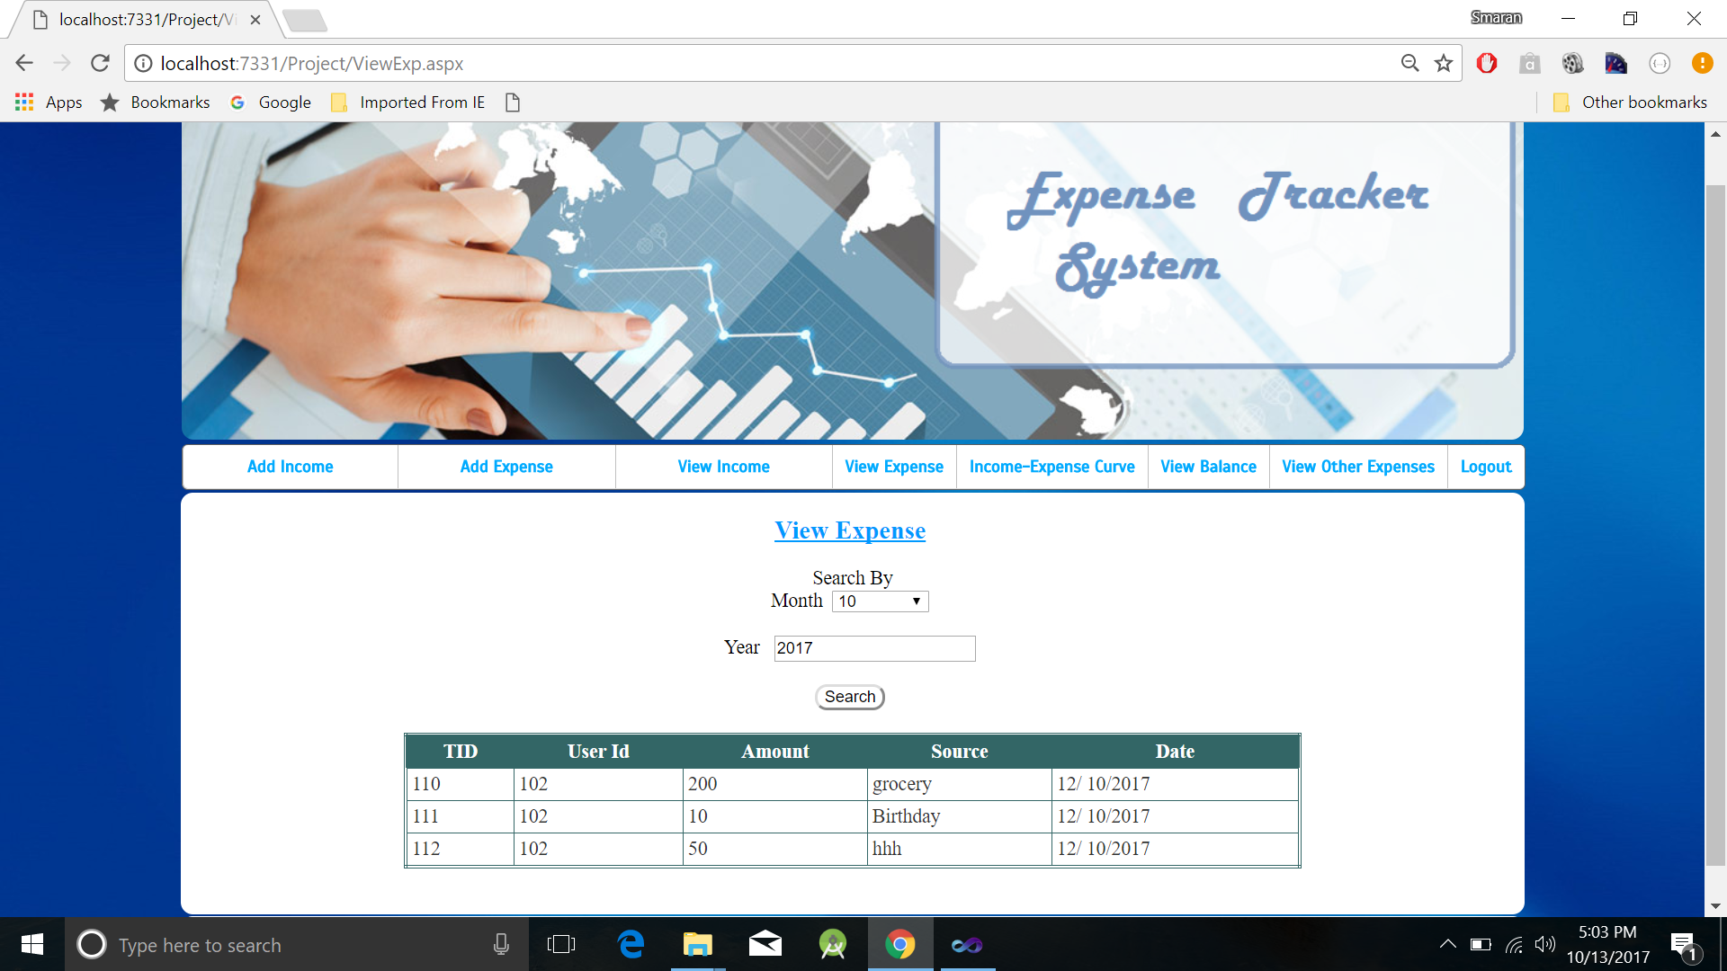

**VIEW BALANCE (AVINASH)**

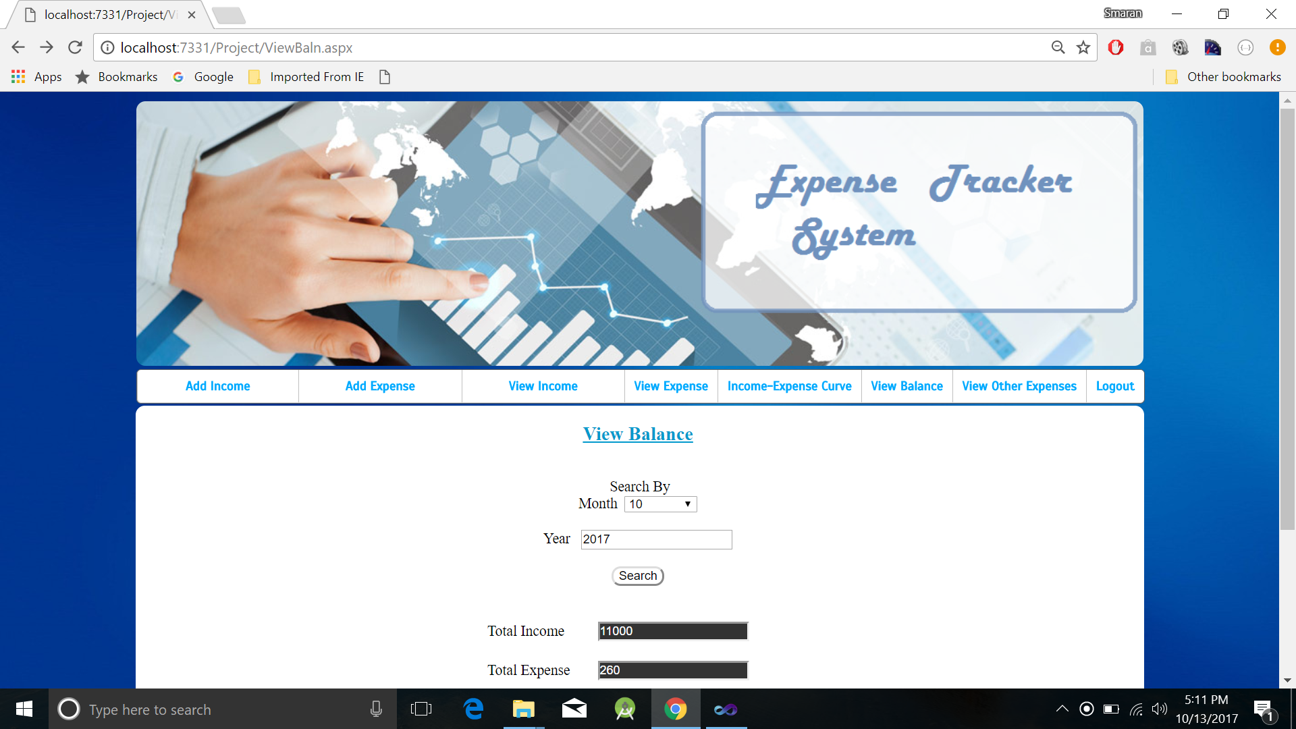

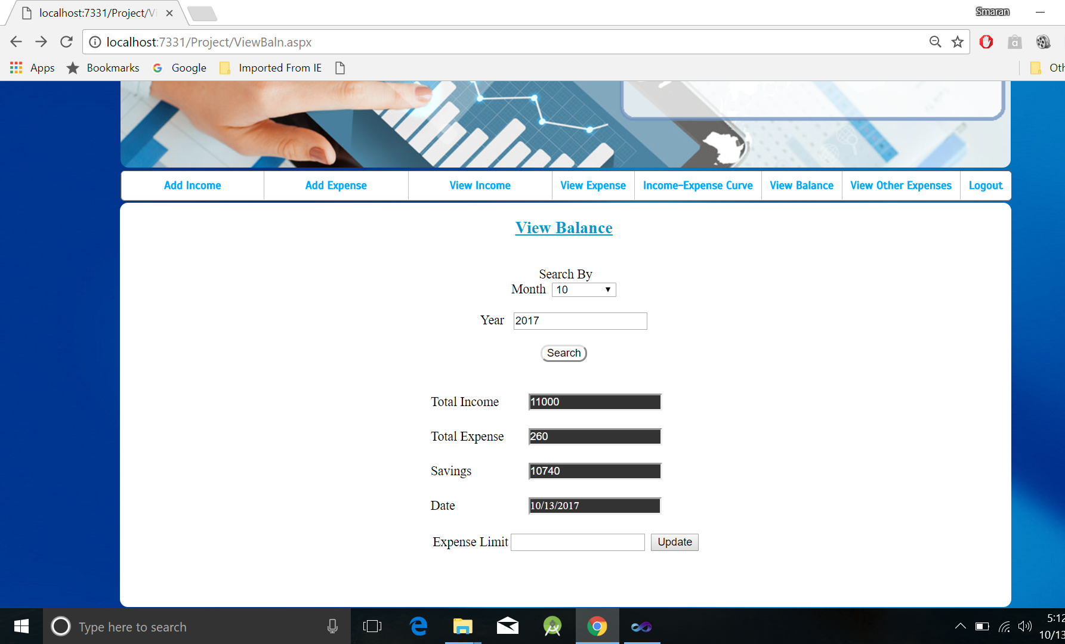

***PROJECT MANAGEMENT (SWETCHA, AVINASH)***

**STATUS REPORT**

***Work completed***

**Description**

* Created issues for Project Increment 2 in GitHub.
* Created wireframes.
* Designed pages of Application
* Login
* Register
* Application page
* Add Income
* Add Expense
* View Income
* View Expense
* View Balance
* Implementation of the pages of the application.

**Responsibility**

**Task Person**

* Ground work for project All four in the team
* Issues Swetcha, Avinash, Smaran
* Wireframes and Pages Design
* Home and View Income Swetcha Reddy Vangala
* View balance and View Expense Avinash Banala
* Register and Add Expense Sai Smaran Chinthala
* Login and Add Income Rahul Nagavalli
* Documentation Avinash Banala
* Local Storage Swetcha Reddy Vangala

**Time taken =** 15 days

**Contribution**

Swetcha Reddy Vangala – 25%

Avinash Banala – 25%

Sai Smaran Chinthala – 25%

Rahul Nagavalli – 25%

***Work to be completed***

**Description**

* Few pages design.
* Actual usage and APIs.
* Development of application.

**Responsibility**

We are going to work collectively as a team to develop our application.

**Time to be taken** = 30 day

**Issues/Concerns** – No issues.

**Bibliography**

<https://www.tutorialspoint.com/csharp/>

<https://docs.microsoft.com/en-us/dotnet/csharp/programming-guide/>

<https://www.w3schools.com/asp/>

<https://www.tutorialspoint.com/asp.net/>

<www.learncs.org/>

<www.fixer.io/>

**PROJECT INCREMENT 2 WIKI PAGE LINK**

[**https://github.com/SwetchaReddy/ASE-Project/wiki/INCREMENT-2**](https://github.com/SwetchaReddy/ASE-Project/wiki/INCREMENT-2)